Music Color
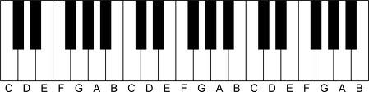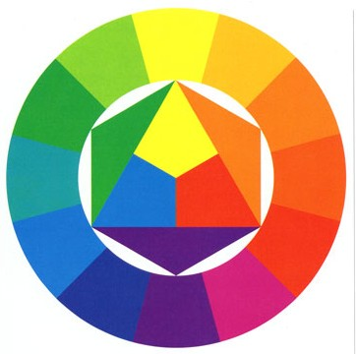
C - E - G E - G - C G - C - E
1 - 3 - 5 3 - 5 - 1 5 - 1 - 3

Geometric Shapes Language
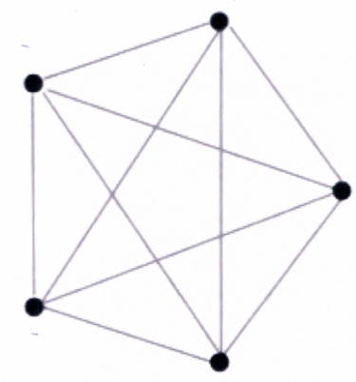
In Poetry
Inversion creates meter and rhythm

In Syntax
Used to highlight qualities/characteristics
Inversions

